Industrial Revolution
DBQ packet

Document 1: House of Lords Committee and Michael Ward, Interview, 1819.

Michael Ward was a doctor in Manchester for 30 years. His practice treated several children who worked in Manchester factories. He was interviewed about the health of textile factory workers on March 25, 1819 by the House of Lords Committee (British Parliament). The exchange below is an excerpt from the interview.

Question: Give the committee information on your knowledge of the health of workers in cotton factories.
Answer: I have had frequent opportunities of seeing people coming out from the factories and occasionally attending as patients. Last summer I visited three cotton factories with Dr. Clough of Preston and Mr. Barker of Manchester, and we could not remain ten minutes in the factory without gasping for breath.

Q: What was your opinion of the relative state of health between cotton-factory children and children in other employments?
A: The state of the health of the cotton-factory children is much worse than that of children employed in other manufactories.

Q: Have you any further information to give to the committee?
A: Cotton factories are highly unfavourable, both to the health and morals of those employed in them. They are really nurseries of disease and vice.

Q: Have you observed that children in the factories have particular accidents?
A: When I was a surgeon in the infirmary, accidents were very often admitted to the infirmary, through the children’s hands and arms having been caught in the machinery; in many instances the muscles and the skin is stripped down to the bone, and in some instances a finger or two might be lost. Last summer I visited Lever Street School. The number of children at that time in the school, who were employed in factories, was 106. The number of children who had received injuries from the machinery amounted to very nearly one half. There were 47 injured in this way.

- Why is Dr. Ward being interviewed by the House of Lords Committee?

- What does he mean when he refers to factories as “nurseries of disease and vice”?

- What evidence does Dr. Ward use to back his claims that factories were unhealthy and unsafe for children?

- Does this document illustrate a POSITIVE or NEGATIVE effect of the Industrial Revolution? (Circle one)

- What is the main idea of this reading?

Document 2: House of Lords Committee and Edward Holme, Interview, 1818

Edward Holme was a physician who lived in Manchester, England during the first half of the nineteenth century. He was an active member of various academic societies and associations and a well-regarded doctor. In 1818, he was interviewed by the House of Lord’s Committee about health conditions of factories. The exchange below is an excerpt from the interview.

Question: How long have you practiced as a physician in Manchester?
Answer: Twenty-four years.

Q: Has that given you the opportunity of observing the state of the children who are ordinarily employed in the cotton factories?
A: It has.

Q: In what state of health did you find the person employed?
A: They were in good health generally. I can give you particulars, if desired, of Mr. Pooley’s factory. He employs 401 persons; and, of the persons examined in 1796, 22 were found to be of delicate appearances, 2 were entered as sickly, 3 in bad health, 1 subject to convulsions, 8 cases of tuberculosis. 363 were in good health.

Q: Am I to understand you, from your investigations in 1796, you formed rather a favorable opinion of the health of persons employed in cotton factories?
A: Yes.

Q: Have you had any occasion to change that opinion since?
A: None whatever. They are as healthy as any other part of the working classes of the community.

Q: Who asked you to undertake the examining of these children in Mr. Pooley’s factory?
A: Mr. Pooley.

- How is the source information for this document similar to and different from Document 1?

- What evidence does Dr. Holme use to back his claim about the health of children in factories? Do you think this is convincing evidence?

- Why might it matter that Mr. Pooley asked Dr. Holme to examine the children at his own factory?

- Does this document illustrate a POSITIVE or NEGATIVE effect of the Industrial Revolution? (Circle one)

- What is the main idea of this reading?

Document 3: John Birley, The Ashton Chronicle, May 19 1849.

John Birley was born in London in 1805. He lost both his parents by the age of 5, and he was sent to the Bethnal Green Workhouse. He soon began working at the Cressbrook factory. John was interviewed about his experiences as a child worker at the Mill in 1849. An article on his life was published in the newspaper, the Ashton Chronicle, in May 1849. Below is an excerpt from the article.

Our regular (working time) time was from 5 in the morning til 9 or 10 at night; and on Saturday, til 11, and often 12 o’clock at night, and then we were sent to clean the machinery on the Sunday. No time was allowed for breakfast and no sitting for dinner and no time for tea. We went to the mill at 5 o’clock and worked till about 8 or 9 when they brought us our breakfast, which consisted of water-porridge, with oatcake in it and onions to flavor it. We then worked ill 9 or 10 at night.

Mr. Needham, the master, had 5 sons: Frank, Charles, Samuel, Robert and John. The sons and a man named Swann, the overlooker, used to go up and down the mill with sticks. Frank once beat me till he frightened himself. He thought he had killed me. He had struck me on the temples and knocked me dateless. He once knocked me down and threatened me with a stick. To save my head I raised my arm, which he then hit with all his might. My elbow was broken. I bear the marks and suffer pain from it to this day, and always shall as long as I live.

I was determined to let the gentleman of the Bethnal Green parish know the treatment we had, and I wrote a letter put it into the Post Office. Sometime after this 3 gentlemen came down from London. But before we were examined we were washed and cleaned up and ordered to tell them we liked working at the mill and were well treated. Needham and his sons were in the room at the time. They asked us questions about our treatment, which we answered as we had been told, not daring to do any other, knowing what would happen if we told them the truth.

- What happened to John Birley?

- Is Birley’s account in the last paragraph trustworthy or not? Why?

- Which document, 1 or 2, does this account more closely match? Explain.

- Does this document illustrate a POSITIVE or NEGATIVE effect of the Industrial Revolution? (Circle one)

- What is the main idea of this reading?

Document 4: Edward Baines, History of the Cotton Manufacture in Great Britain, 1835.

Edward Baines was a newspaper journalist and editor for the Leeds Mercury Newspaper. In the 1830s, he was elected to Parliament, and served there as a political liberal. Although Baines supported the end of slavery and various political reforms, he opposed legislation regulating factories and extending voting rights to the English working class. These are excerpts from his book History of the Cotton Manufacture in Great Britain.

Above all, it is alleged that the children who labor in mills are often cruelly beaten by overlookers, that their feeble limbs become distorted by continual standing and stooping, that in many mills they are forced to work 13, 14 or 15 hours per day, and that they have not time either for play or for education.

Factory inspectors who have visited nearly every mill in the country have proved that views mentioned above of labor in factory mills contain a very small portion of truth. It is definitely true that there have been instances of abuse and cruelty in some factories. But abuse is the exception, not the rule. Factory labor is far less injurious than many of the most common jobs of civilized life.

The human frame is liable to an endless variety of diseases. Many of the children who are born into the world and attain the age of 10 or 12 years are so weak, that under any circumstances they would die early. Such children would sink under factory labor, as they would under any other kind of labor, or even without labor.

I am not saying that factories are the most agreeable and healthy places, or that there have not been abuses in them, which required exposure and correction. It must be admitted that the hours of labor in cotton mills are long, being 12 hours a day on 5 days a week, and 9 hours on Saturday. But the work is light and requires very little muscular exertion. It is scarcely possible for any job to be lighter. The position of the body is not injurious: the children walk about, and have opportunity to sit down frequently if they want to. On visiting mills, I have noticed the coolness and calmness of the work-people, even of the children, whose attitudes are positive and not anxious or gloomy.

- What does Baines mean in the second paragraph, when he states “but abuse is the exception no the rule”?

- What is Baines’ main point in the final paragraph?

- Which document, 1 or 2, does this account more closely match? Explain.

- Does this document illustrate a POSITIVE or NEGATIVE effect of the Industrial Revolution? (Circle one)

- What is the main idea of this reading?

Document 5: Typical working class neighborhood in London, England, 1872

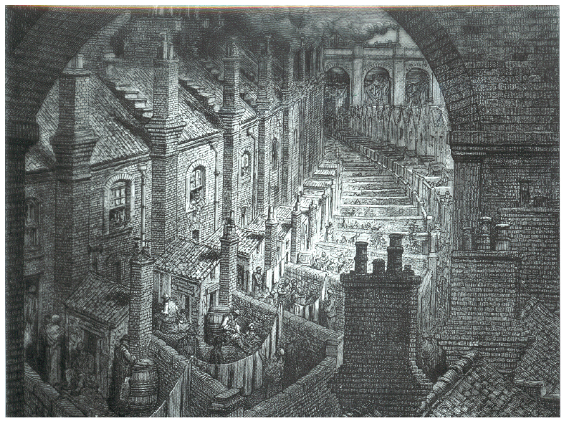

- What does this image show about living conditions in England?

- Why do you think these living conditions existed?

- What challenges might these living conditions pose to English workers?

- Does this document illustrate a POSITIVE or NEGATIVE effect of the Industrial Revolution? (Circle one)

- What is the main idea of this reading?

Document 6:
- Image on right: R. Guest, A Compendious History of the Cotton Manufacture, 1823
- Image on left: The Illustrated London News, August 25, 1883

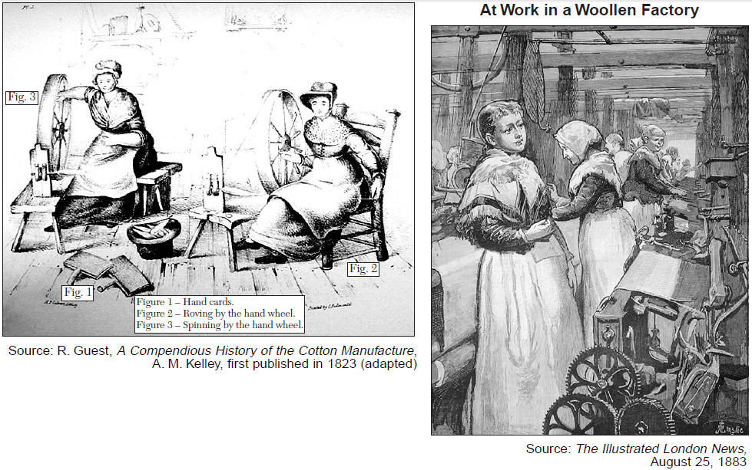
- According to the image on the left, 2. According to the image on the right,
how was cotton made in the early 1800s? how was cotton made in the late 1800s?

- How did the production of cotton change in the 1800s?

- How might this change be positive for workers? 5. Negative?

- Does this document illustrate a POSITIVE or NEGATIVE effect of the Industrial Revolution? (Circle one)

- What is the main idea of this reading?

Document 7: Andrew Ure, The Philosophy of Manufactures, 1835

Steam engines furnish the means not only of their support but of their multiplication. They create a vast demand for fuel; and, while they lend their powerful arms to drain the pits and to raise the coals, they call into employment multitudes of miners, engineers, ship-builders, and sailors, and cause the construction of canals and railways. And, while they enable these rich fields of industry to be cultivated to the utmost, they leave thousands of fine arable [farmable] fields free for the production of food to man, which must have been otherwise allotted to the food of horses. Steam engines, moreover, by the cheapness and steadiness of their action, fabricate [produce] cheap goods, and produce [acquire] in their exchange a liberal supply of the necessaries and comforts of life, produced in foreign lands.

- Please list two ways that steam engines have helped the economy in England.

- What specific characteristics of steam engines allow them to be so beneficial?

- Does this document illustrate a POSITIVE or NEGATIVE effect of the Industrial Revolution? (Circle one)

- What is the main idea of this reading?

Document 8: Industrialization and Demographic Change, World Civilizations: Sources, Images and Interpretations, McGraw-Hill

- Describe population density in 1801. 2. Describe population density in 1851.

- Why do you think this change occurred?

- How might this change be positive for Englishmen? 5. Negative?

- Does this document illustrate a POSITIVE or NEGATIVE effect of the Industrial Revolution? (Circle one)

- What is the main idea of this reading?

Document 9: Edwin Chadwick, Report on an Inquiry into the Sanitary Condition of the Laboring Population of Great Britain, W. Clowes and Sons, 1842

Edwin Chadwick presented a report to Parliament as secretary to a commission that investigated sanitary conditions and means of improving them.

... First, as to the extent and operation of the evils which are the subject of the inquiry [investigation]...

The formation of all habits of cleanliness is obstructed by defective supplies of water.

The annual loss of life from filth and bad ventilation is greater than the loss from death or wounds in any wars in which the country has been engaged in modern times.

That of the 43,000 cases of widowhood and 112,000 cases of destitute orphanage relieved from the poor’s rates of England and Wales alone, it appears that the greatest proportion of deaths of the heads of families occurred from the above specified and other preventable causes; that their ages were under 45 years, 13 years below the natural probabilities of life.

- Based on this document, state one negative effect of industrialization.

- Why do you think this negative effect occurred?

- Why do you think Edwin Chadwick is presenting this information to Parliament? What is his goal?

- Does this document illustrate a POSITIVE or NEGATIVE effect of the Industrial Revolution? (Circle one)

- What is the main idea of this reading?

Document 10: The Conditions of the Working Class in England, Friedrich Engels, 1844

Every great town has one of more slum areas where workers struggle through life as best they can out of sight of the more fortunate classes of society. The slums are generally an unplanned wilderness of one – or two – stories houses. Wherever possible these have cellars which are also used as dwellings [homes]. The streets are usually unpaved, full of holes, filthy and strewn [scattered] with refuse [trash]. Since they have neither gutters nor drains, the refuse accumulates in stagnant, stinking puddles. The view of Manchester is quite typical. The main river is narrow, coal-black and full of stinking filth and rubbish which deposits on the bank. One walks along a very rough path on the river bank to reach a chaotic group of little one story, one room cabins. In front of the doors, filth and garbage abound.

- How does Engels describe towns in England?

- Why do you think these slums exist?

- Why do you think the rivers are “coal-black and full of stinking filth”?

- Does this document illustrate a POSITIVE or NEGATIVE effect of the Industrial Revolution? (Circle one)

- What is the main idea of this reading?

